# UTS CSEC CTF FLAG WRITEUP

### Title: Torturous

**Date made: 5/04/20**

**Author: Crem**

**Used in what CSEC CTF: Aut 2020**

**Flag:** CSEC{you_have_beaten_the_cyclops}

**Difficulty: Medium**

**Category: Forensics**

**Description:**

Odysseus went on a torturous journey in the book ‘The Odyessey’. You will probably have to go on a torturous journey to get this flag too.

**Hint(s):**

**Writeup:**

1. Download “Odyessey.txt”
2. Look through text file and somewhere in the middle of the text file, there is a huge string. You have to identify that it is a base64 string by the equal sign at the end.
3. If you decode it, it look like this:

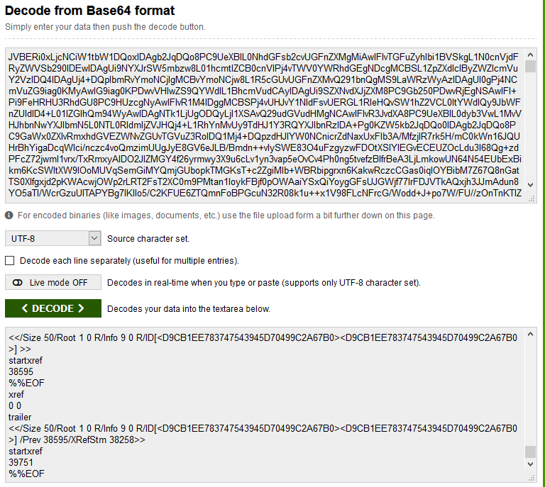

1. It shows that it is actually a PDF document. If you go to this website that can convert Base64 to PDF. <https://base64.guru/converter/decode/pdf>
2. When base64 it says “good work now what type of file is this?” If you research it is a PDF so you put the PDF magic bytes in. Rebase64 it. :)
3. Paste the base64 into the website and click convert.

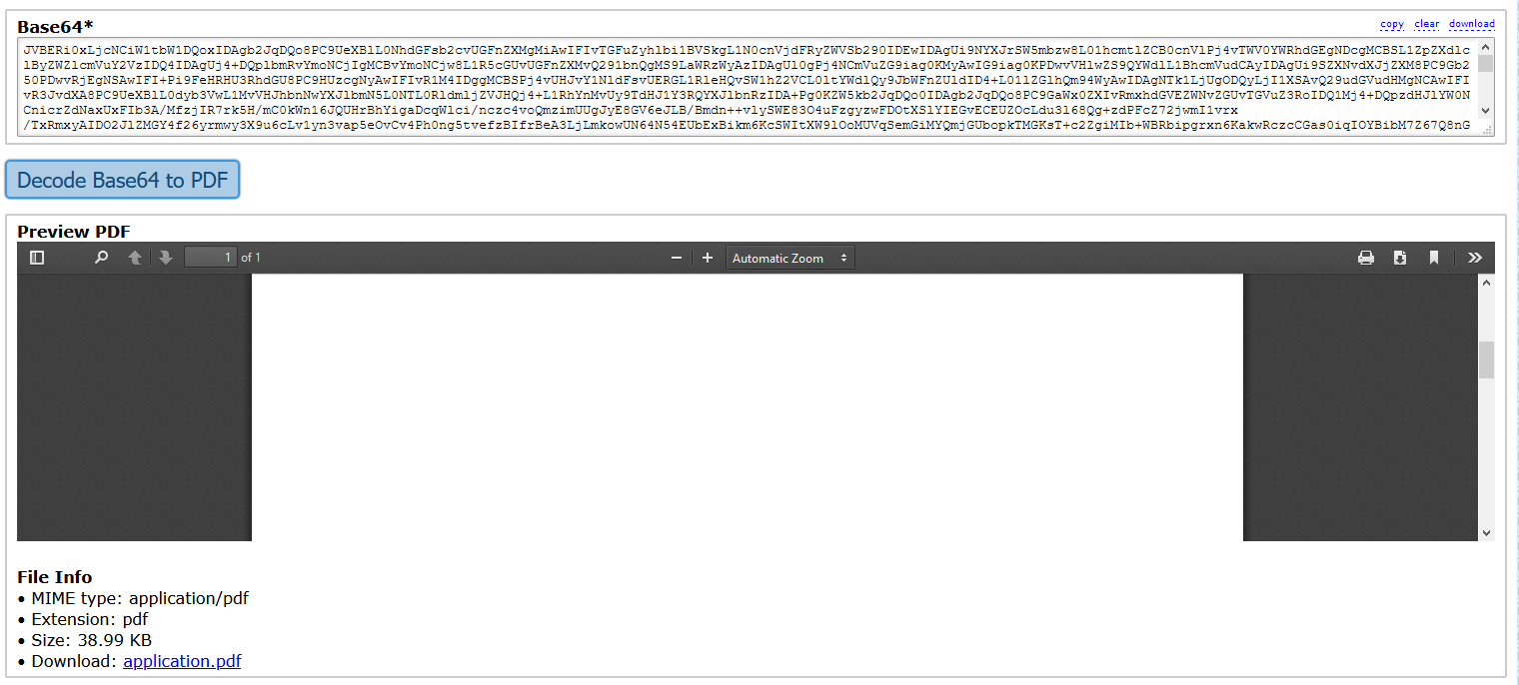

1. You can either choose to download it or view it on the website. However, the PDF looks blank and 17 pages. However, if you press Ctrl + A or highlight a bunch of stuff there is actually white text which is the flag.
2. Get flag which is “CSEC{you_have_beaten_the_cyclops}” and receive your points.

CSEC{}